ReactJS tutorial

# React Introduction

ReactJS is a declarative, efficient, and flexible JavaScript library for building reusable UI components. It is an open-source, component-based front end library responsible only for the view layer of the application. It was created by **Jordan Walke,** who was a software engineer at **Facebook.** It was initially developed and maintained by Facebook and was later used in its products like **WhatsApp** & **Instagram.** Facebook developed ReactJS in **2011** in its newsfeed section, but it was released to the public in the month of **May 2013.**

A ReactJS application is made up of multiple components, each component responsible for outputting a small, reusable piece of HTML code. The components are the heart of all React applications. These Components can be nested with other components to allow complex applications to be built of simple building blocks. ReactJS uses virtual DOM based mechanism to fill data in HTML DOM. The virtual DOM works fast as it only changes individual DOM elements instead of reloading complete DOM every time.

To create React app, we write React components that correspond to various elements. We organize these components inside higher level components which define the application structure. For example, we take a form that consists of many elements like input fields, labels, or buttons. We can write each element of the form as React components, and then we combine it into a higher-level component, i.e., the form component itself. The form components would specify the structure of the form along with elements inside of it.

# Why learn ReactJS?

Today, many JavaScript frameworks are available in the market(like angular, node), but still, React came into the market and gained popularity amongst them. The previous frameworks follow the traditional data flow structure, which uses the DOM (Document Object Model). DOM is an object which is created by the browser each time a web page is loaded. It dynamically adds or removes the data at the back end and when any modifications were done, then each time a new DOM is created for the same page. This repeated creation of DOM makes unnecessary memory wastage and reduces the performance of the application.

Therefore, a new technology ReactJS framework invented which remove this drawback. ReactJS allows you to divide your entire application into various components. ReactJS still used the same traditional data flow, but it is not directly operating on the browser's Document Object Model (DOM) immediately; instead, it operates on a virtual DOM. It means rather than manipulating the document in a browser after changes to our data, it resolves changes on a DOM built and run entirely in memory. After the virtual DOM has been updated, React determines what changes made to the actual browser's DOM. The React Virtual DOM exists entirely in memory and is a representation of the web browser's DOM. Due to this, when we write a React component, we did not write directly to the DOM; instead, we are writing virtual components that react will turn into the DOM.

# React create-react-app

Starting a new React project is very complicated, with so many build tools. It uses many dependencies, configuration files, and other requirements such as Babel, Webpack, ESLint before writing a single line of React code. Create React App CLI tool removes all that complexities and makes React app simple. For this, you need to install the package using NPM, and then run a few simple commands to get a new React project.

The **create-react-app**  allows you to create and run React project very quickly. This tool is wrapping all of the required dependencies like **Webpack**, **Babel** for React project itself and then you need to focus on writing React code only. This tool sets up the development environment, provides an excellent developer experience, and optimizes the app for production.

## Requirements

The Create React App is maintained by Facebook and can works on any platform, for example, macOS, Windows, Linux, etc. To create a React Project using create-react-app, you need to have installed the following things in your system.

1. Node version >= 8.10
2. NPM version >= 5.6

## Installation

Here, we are going to learn how we can install React using *CRA* tool. For this, we need to follow the steps as given below.

### Install React

We can install React using npm package manager by using the following command. There is no need to worry about the complexity of React installation. The create-react-app npm package manager will manage everything, which needed for React project.

**C:\Users\javatpoint> npm install -g create-react-app**

### Create a new React project

Once the React installation is successful, we can create a new React project using create-react-app command. Here, I choose "reactproject" name for my project.

**C:\Users\javatpoint> create-react-app reactproject**

#### NOTE: We can combine the above two steps in a single command using npx. The npx is a package runner tool which comes with npm 5.2 and above version.

**C:\Users\javatpoint> npx create-react-app reactproject**

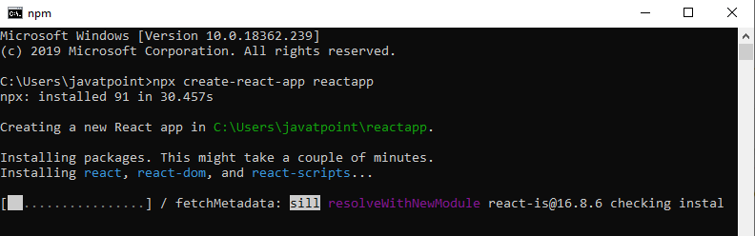

The above command will take some time to install the React and create a new project with the name "reactproject." Now, we can see the terminal as like below.

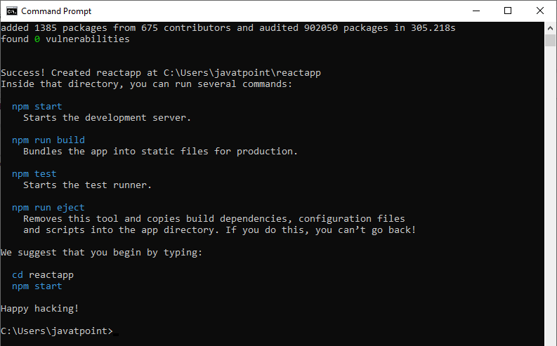

The above screen tells that the React project is created successfully on our system. Now, we need to start the server so that we can access the application on the browser. Type the following command in the terminal window.

**$ cd Desktop**

**$ npm start**

NPM is a package manager which starts the server and access the application at default server [http://localhost:3000](http://localhost:3000/). Now, we will get the following screen.

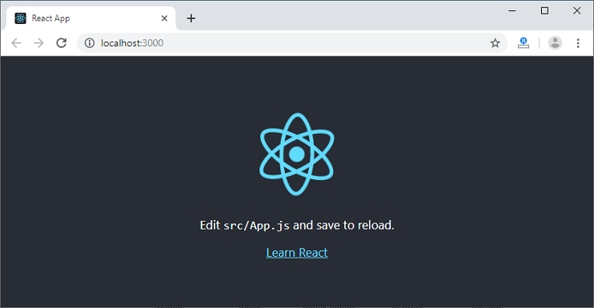

Next, open the project on Code editor. Here, I am using Visual Studio Code. Our project's default structure looks like as below image.

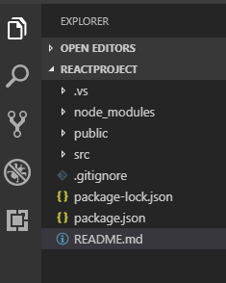

In React application, there are several files and folders in the root directory. Some of them are as follows:

* node_modules: It contains the React library and any other third party libraries needed.
* public: It holds the public assets of the application. It contains the index.html where React will mount the application by default on the <div id="root"></div> element.
* src: It contains the App.css, App.js, App.test.js, index.css, index.js, and serviceWorker.js files. Here, the App.js file always responsible for displaying the output screen in React.
* package-lock.json: It is generated automatically for any operations where npm package modifies either the node_modules tree or package.json. It cannot be published. It will be ignored if it finds any other place rather than the top-level package.
* package.json: It holds various metadata required for the project. It gives information to npm, which allows to identify the project as well as handle the project?s dependencies.
* README.md: It provides the documentation to read about React topics.

### React Environment Setup

Now, open the src >> App.js file and make changes which you want to display on the screen. After making desired changes, save the file. As soon as we save the file, Webpack recompiles the code, and the page will refresh automatically, and changes are reflected on the browser screen. Now, we can create as many components as we want, import the newly created component inside the App.js file and that file will be included in our main index.html file after compiling by Webpack.

Next, if we want to make the project for the production mode, type the following command. This command will generate the production build, which is best optimized.

**$ npm build**

# React Features

Currently, ReactJS gaining quick popularity as the best JavaScript framework among web developers. It is playing an essential role in the front-end ecosystem. The important features of ReactJS are as following.

* **JSX**
* **Components**
* **One-way Data Binding**
* **Virtual DOM**
* **Simplicity**
* **Performance**

### JSX

JSX stands for JavaScript XML. It is a JavaScript syntax extension. Its an XML or HTML like syntax used by ReactJS. This syntax is processed into JavaScript calls of React Framework. It extends the ES6 so that HTML like text can co-exist with JavaScript react code. It is not necessary to use JSX, but it is recommended to use in ReactJS.

### Components

ReactJS is all about components. ReactJS application is made up of multiple components, and each component has its own logic and controls. These components can be reusable which help you to maintain the code when working on larger scale projects.

### One-way Data Binding

ReactJS is designed in such a manner that follows unidirectional data flow or one-way data binding. The benefits of one-way data binding give you better control throughout the application. If the data flow is in another direction, then it requires additional features. It is because components are supposed to be immutable and the data within them cannot be changed. Flux is a pattern that helps to keep your data unidirectional. This makes the application more flexible that leads to increase efficiency.

### Virtual DOM

A virtual DOM object is a representation of the original DOM object. It works like a one-way data binding. Whenever any modifications happen in the web application, the entire UI is re-rendered in virtual DOM representation. Then it checks the difference between the previous DOM representation and new DOM. Once it has done, the real DOM will update only the things that have actually changed. This makes the application faster, and there is no wastage of memory.

### Simplicity

ReactJS uses JSX file which makes the application simple and to code as well as understand. We know that ReactJS is a component-based approach which makes the code reusable as your need. This makes it simple to use and learn.

### Performance

ReactJS is known to be a great performer. This feature makes it much better than other frameworks out there today. The reason behind this is that it manages a virtual DOM. The DOM is a cross-platform and programming API which deals with HTML, XML or XHTML. The DOM exists entirely in memory. Due to this, when we create a component, we did not write directly to the DOM. Instead, we are writing virtual components that will turn into the DOM leading to smoother and faster performance.

# Pros and Cons of ReactJS

Today, ReactJS is the highly used open-source JavaScript Library. It helps in creating impressive web apps that require minimal effort and coding. The main objective of ReactJS is to develop User Interfaces (UI) that improves the speed of the apps. There are important pros and cons of ReactJS given as following:

### Advantage of ReactJS

**1. Easy to Learn and USe**

ReactJS is much easier to learn and use. It comes with a good supply of documentation, tutorials, and training resources. Any developer who comes from a JavaScript background can easily understand and start creating web apps using React in a few days. It is the V(view part) in the MVC (Model-View-Controller) model, and referred to as ?one of the JavaScript frameworks.? It is not fully featured but has the advantage of open-source JavaScript User Interface(UI) library, which helps to execute the task in a better manner.

**2. Creating Dynamic Web Applications Becomes Easier**

To create a dynamic web application specifically with HTML strings was tricky because it requires a complex coding, but React JS solved that issue and makes it easier. It provides less coding and gives more functionality. It makes use of the JSX(JavaScript Extension), which is a particular syntax letting HTML quotes and HTML tag syntax to render particular subcomponents. It also supports the building of machine-readable codes.

**3. Reusable Components**

A ReactJS web application is made up of multiple components, and each component has its own logic and controls. These components are responsible for outputting a small, reusable piece of HTML code which can be reused wherever you need them. The reusable code helps to make your apps easier to develop and maintain. These Components can be nested with other components to allow complex applications to be built of simple building blocks. ReactJS uses virtual DOM based mechanism to fill data in HTML DOM. The virtual DOM works fast as it only changes individual DOM elements instead of reloading complete DOM every time.

**4. Performance Enhancement**

ReactJS improves performance due to virtual DOM. The DOM is a cross-platform and programming API which deals with HTML, XML or XHTML. Most of the developers faced the problem when the DOM was updated, which slowed down the performance of the application. ReactJS solved this problem by introducing virtual DOM. The React Virtual DOM exists entirely in memory and is a representation of the web browser's DOM. Due to this, when we write a React component, we did not write directly to the DOM. Instead, we are writing virtual components that react will turn into the DOM, leading to smoother and faster performance.

**5. The Support of Handy Tools**

React JS has also gained popularity due to the presence of a handy set of tools. These tools make the task of the developers understandable and easier. The React Developer Tools have been designed as Chrome and Firefox dev extension and allow you to inspect the React component hierarchies in the virtual DOM. It also allows you to select particular components and examine and edit their current props and state.

**6. Known to be SEO Friendly**

Traditional JavaScript frameworks have an issue in dealing with SEO. The search engines generally having trouble in reading JavaScript-heavy applications. Many web developers have often complained about this problem. ReactJS overcomes this problem that helps developers to be easily navigated on various search engines. It is because React.js applications can run on the server, and the virtual DOM will be rendering and returning to the browser as a regular web page.

**7. The Benefit of Having JavaScript Library**

Today, ReactJS is choosing by most of the web developers. It is because it is offering a very rich JavaScript library. The JavaScript library provides more flexibility to the web developers to choose the way they want.

**8. Scope for Testing the Codes**

ReactJS applications are extremely easy to test. It offers a scope where the developer can test and debug their codes with the help of native tools.

### Disadvantage of ReactJS

**1. The high pace of development**

The high pace of development has an advantage and disadvantage both. In case of disadvantage, since the environment continually changes so fast, some of the developers not feeling comfortable to relearn the new ways of doing things regularly. It may be hard for them to adopt all these changes with all the continuous updates. They need to be always updated with their skills and learn new ways of doing things.

**2. Poor Documentation**

It is another cons which are common for constantly updating technologies. React technologies updating and accelerating so fast that there is no time to make proper documentation. To overcome this, developers write instructions on their own with the evolving of new releases and tools in their current projects.

**3. View Part**

ReactJS Covers only the UI Layers of the app and nothing else. So you still need to choose some other technologies to get a complete tooling set for development in the project.

**4. JSX as a barrier**

ReactJS uses JSX. It's a syntax extension that allows HTML with JavaScript mixed together. This approach has its own benefits, but some members of the development community consider JSX as a barrier, especially for new developers. Developers complain about its complexity in the learning curve.

# React JSX

As we have already seen that, all of the React components have a render function. The render function specifies the HTML output of a React component. JSX(JavaScript Extension), is a React extension which allows writing JavaScript code that looks like HTML. In other words, JSX is an HTML-like syntax used by React that extends ECMAScript so that HTML-like syntax can co-exist with JavaScript/React code. The syntax is used by preprocessors (i.e., transpilers like babel) to transform HTML-like syntax into standard JavaScript objects that a JavaScript engine will parse.

JSX provides you to write HTML/XML-like structures (e.g., DOM-like tree structures) in the same file where you write JavaScript code, then preprocessor will transform these expressions into actual JavaScript code. Just like XML/HTML, JSX tags have a tag name, attributes, and children.

### Example

Here, we will write JSX syntax in JSX file and see the corresponding JavaScript code which transforms by preprocessor(babel).

**JSX File**

**<div>Hello JavaTpoint</div>**

**Corresponding Output**

**React.createElement("div", null, "Hello JavaTpoint");**

The above line creates a **react element** and passing **three arguments** inside where the first is the name of the element which is div, second is the **attributes** passed in the div tag, and last is the **content** you pass which is the "Hello JavaTpoint."

### Why use JSX?

* It is faster than regular JavaScript because it performs optimization while translating the code to JavaScript.
* Instead of separating technologies by putting markup and logic in separate files, React uses components that contain both. We will learn components in a further section.
* It is type-safe, and most of the errors can be found at compilation time.
* It makes easier to create templates.

### Nested Elements in JSX

To use more than one element, you need to wrap it with one container element. Here, we use **div** as a container element which has **three** nested elements inside it.

**App.JSX**

1. ***import****React, { Component } from 'react';*
2. ***class****App****extends****Component{*
3. *render(){*
4. ***return****(*
5. *<div>*
6. *<h1>JavaTpoint</h1>*
7. *<h2>Training Institutes</h2>*
8. *<p>This website contains the best CS tutorials.</p>*
9. *</div>*
10. *);*
11. *}*
12. *}*
13. *export****default****App;*

**Output:**

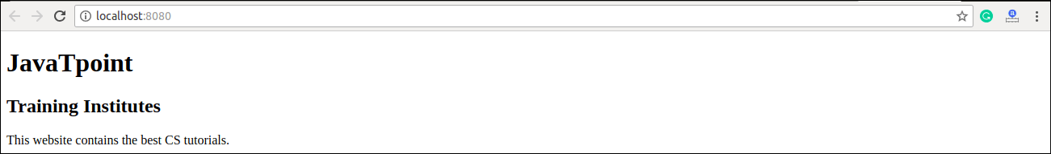

### JSX Attributes

JSX use attributes with the HTML elements same as regular HTML. JSX uses **camelcase** naming convention for attributes rather than standard naming convention of HTML such as a class in HTML becomes **className** in JSX because the class is the reserved keyword in JavaScript. We can also use our own custom attributes in JSX. For custom attributes, we need to use **data- prefix**. In the below example, we have used a custom attribute **data-demoAttribute** as an attribute for the **<p>** tag.

**Example:**

1. ***import React, { Component } from 'react';***
2. ***class App extends Component{***
3. ***render(){***
4. ***return(***
5. ***<div>***
6. ***<h1>JavaTpoint</h1>***
7. ***<h2>Training Institutes</h2>***
8. ***<p data-demoAttribute = "demo">This website contains the best CS tutorials.</p>***
9. ***</div>***
10. ***);***
11. ***}***
12. ***}***
13. ***export default App;***

**In JSX, we can specify attribute values in two ways:**

**1. As String Literals:** We can specify the values of attributes in double quotes:

**var element = <h2 className = "firstAttribute">Hello JavaTpoint</h2>;**

**Example**

1. ***import****React, { Component } from 'react';*
2. ***class****App****extends****Component{*
3. *render(){*
4. ***return****(*
5. *<div>*
6. *<h1 className = "hello" >JavaTpoint</h1>*
7. *<p data-demoAttribute = "demo">This website contains the best CS tutorials.</p>*
8. *</div>*
9. *);*
10. *}*
11. *}*
12. *export****default****App;*

**Output:**

JavaTpoint

This website contains the best CS tutorials.

**2. As Expressions:** We can specify the values of attributes as expressions using curly braces {}:

**var element = <h2 className = {varName}>Hello JavaTpoint</h2>;**

**Example**

1. ***import****React, { Component } from 'react';*
2. ***class****App****extends****Component{*
3. *render(){*
4. ***return****(*
5. *<div>*
6. *<h1 className = "hello" >{25+20}</h1>*
7. *</div>*
8. *);*
9. *}*
10. *}*
11. *export****default****App;*

**Output:**

**45**

### JSX Comments

JSX allows us to use comments that begin with /* and ends with */ and wrapping them in curly braces {} just like in the case of JSX expressions. Below example shows how to use comments in JSX.

Example:

1. ***import****React, { Component } from 'react';*
2. ***class****App****extends****Component{*
3. *render(){*
4. ***return****(*
5. *<div>*
6. *<h1 className = "hello" >Hello JavaTpoint</h1>*
7. *{/* This is a comment in JSX */}*
8. *</div>*
9. *);*
10. *}*
11. *}*
12. *export****default****App;*

### JSX Styling

React always recommends to use **inline** styles. To set inline styles, you need to use **camelCase** syntax. React automatically allows appending **px** after the number value on specific elements. The following example shows how to use styling in the element.

Example

1. *import React, { Component } from 'react';*
2. *class App extends Component{*
3. *render(){*
4. *var myStyle = {*
5. *fontSize: 80,*
6. *fontFamily: 'Courier',*
7. *color: '#003300'*
8. *}*
9. *return (*
10. *<div>*
11. *<h1 style = {myStyle}>www.javatpoint.com</h1>*
12. *</div>*
13. *);*
14. *}*
15. *}*
16. *export default App;*

**Output:**

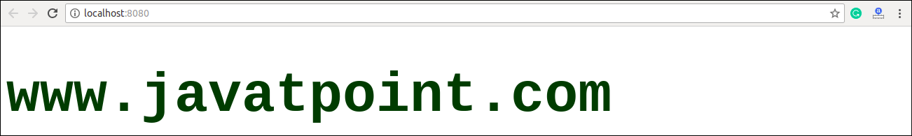

#### NOTE: JSX cannot allow to use if-else statements. Instead of it, you can use conditional (ternary) expressions. It can be seen in the following example.

Example:

1. ***import****React, { Component } from 'react';*
2. ***class****App****extends****Component{*
3. *render(){*
4. *var i = 5;*
5. ***return****(*
6. *<div>*
7. *<h1>{i == 1 ? 'True!' : 'False!'}</h1>*
8. *</div>*
9. *);*
10. *}*
11. *}*
12. *export****default****App;*

**Output:**

False!